**Employee Directory Task**

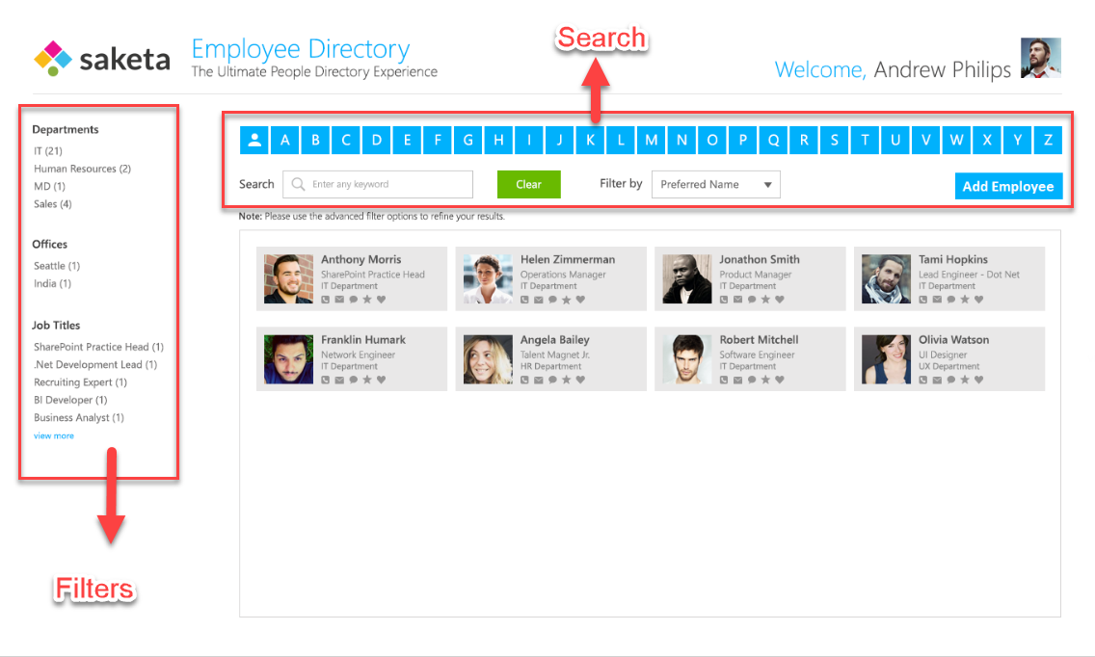

1. The directory homepage should be designed as the mock-up above.
2. Employee will have properties like

* First Name
* Last Na
* Preferred Name (auto populated from First Name and Last Name)
* Email
* Job Title
* Office
* Department
* Phone Number
* Skype ID

1. Create a pop-up to add new employees with all the above properties with validations.
2. Employees should be searchable by properties mentioned above.
3. Search should be available by both Alphabet and input on selected Filter By property. (See search in Image)
4. Functionality should be added to filter employees by Department, Offices and Job Title. (See filters in image)
5. On clicking Employee card, Employee Details pop-up should be displayed with all employee details.
6. Employee Details should have an option to edit the details inline.